Assignment 3

Program to write the first 10 numbers.

Program:

for(let i=0; i<10; i++){

if(i>10){

break;

}

console.log(i)

}

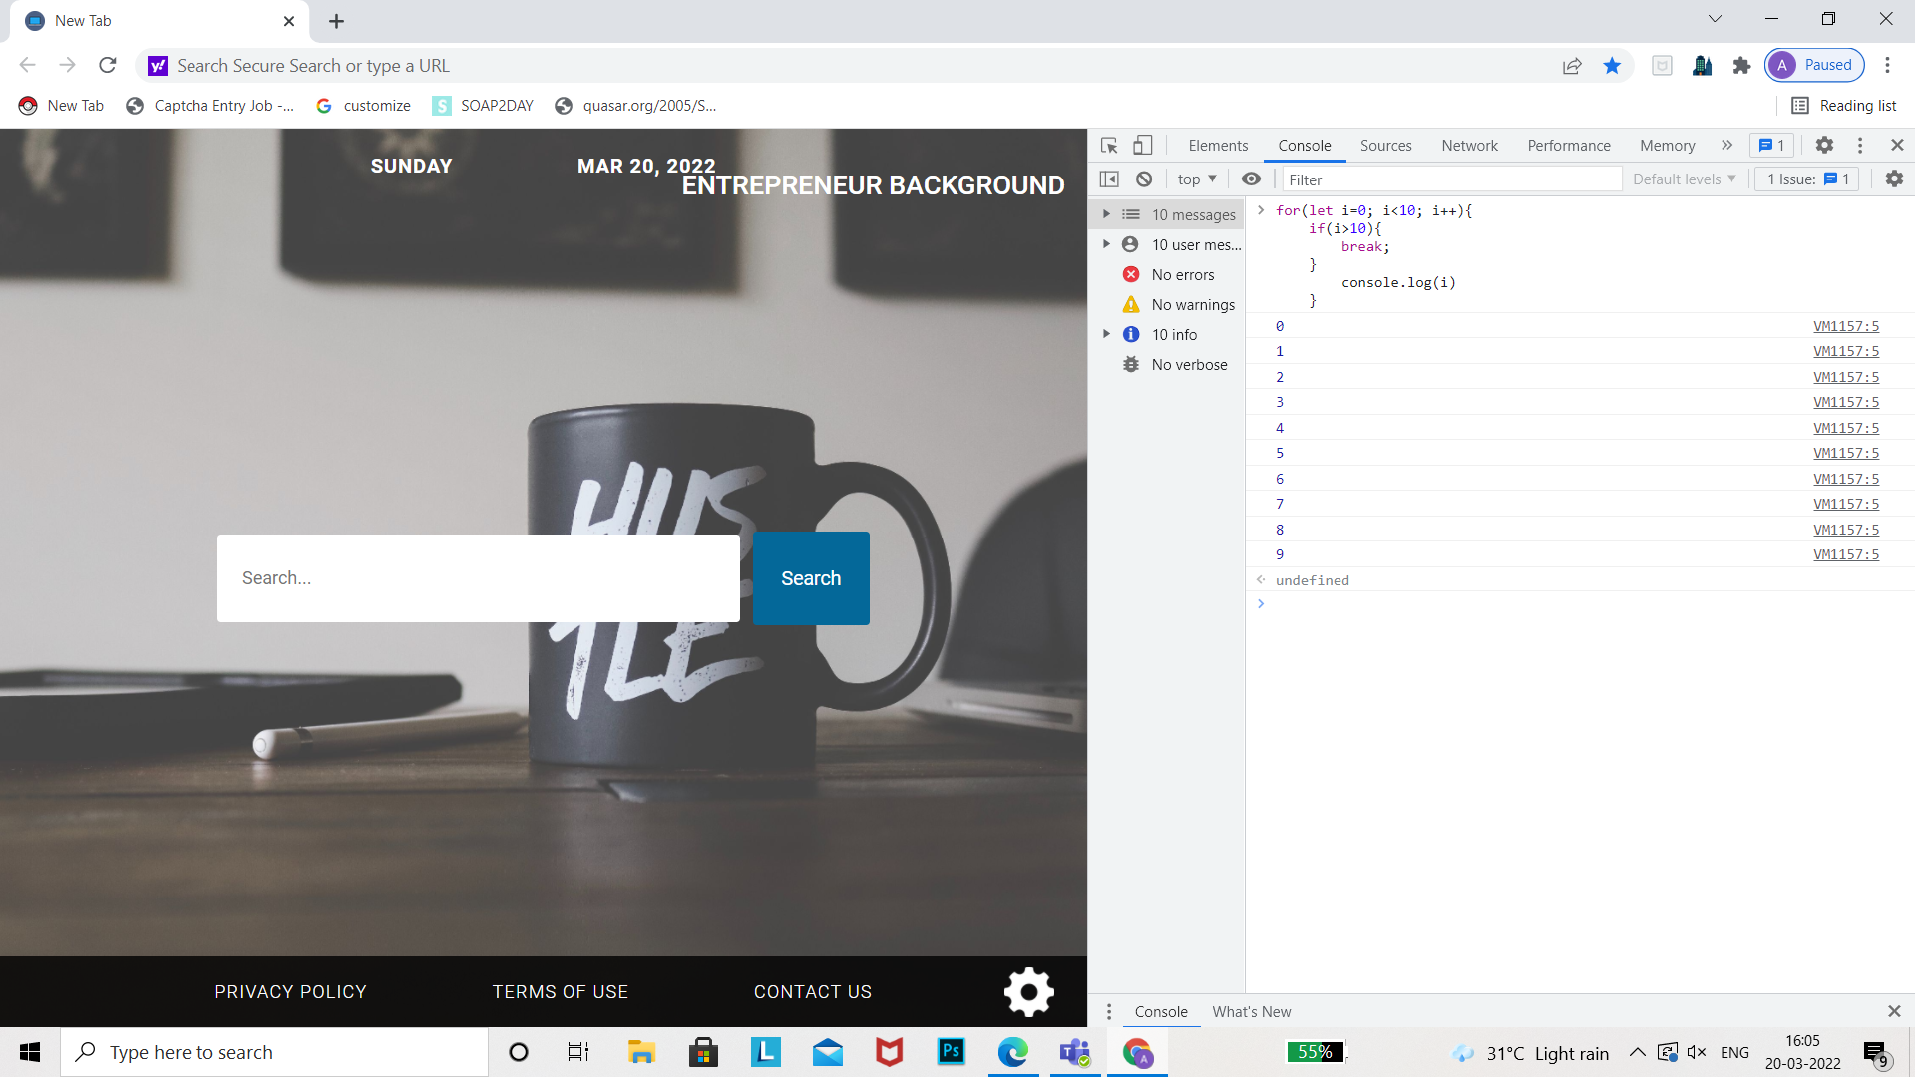

Make a loop stop when I is 5.

Program:

for(let i=0; i<10; i++){

if(i==5){

break;

}

console.log(i)

}

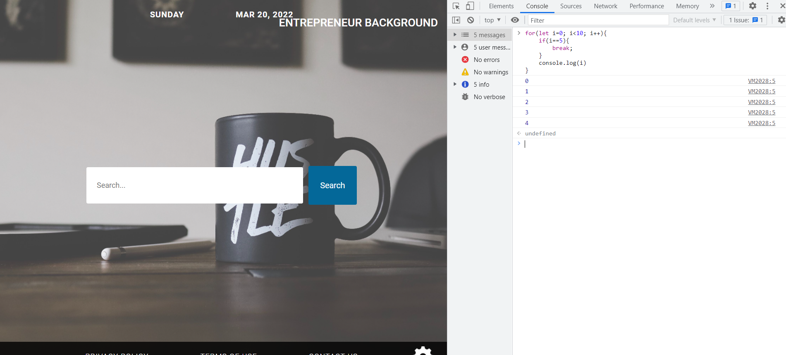

Program to calculate the sum of first 10 numbers.

Program:

Let sum=0;

For(let i=0; i<10; i++){

Read number

Sum=sum+number

Console.log(i)

}

Write a program to print day of week name using switch case.

Program:

Let week;

Switch(week)

{

Case 1: print ‘Sunday’

break;

Case 2: print ‘Monday’

break;

Case 3: print ‘Tuesday’

break ;

Case 4: print ‘Wednesday’

break;

Case 5: print ‘Thursday’

break;

Case 6: print ‘Friday’

break;

Case 7: print ‘Saturday’

break;

default: print ‘Invalid input’

}

Write a program to print total number of days in a month using switch case.

Let month;

Switch(month){

Case1: print ’31 days’

break;

Case2: print ’28/29 days’

break;

Case3: print ’31 days’

break;

Case4: print ’30 days’

break;

Case5: print ’31 days’

break;

Case6: print ’30 days’

break;

Case7: print ’31 days’

break;

Case8: print ’31 days’

break;

Case9: print ’30 days’

break;

Case10: print ’31 days’

break;

Case11: print ’30 days’

break;

Case12: print ’31 days’

break;

default: print ‘invalid input enter a valid month’

}